**Assessment** : Information Technology & Problem Solving

1. **Logical thinking**

#include <iostream>

int largestOdd(int array[], int numValues);

int main()

{

int someArray[] = {3, 5, 6, 2, 7, 1, 0, 8};

int lOdd = largestOdd( someArray, 7);

std: :cout<< "The largest odd number is " << lOdd;

}

int largestOdd(int array[], int numValues)

1. **Tools Understanding**

Response that I got using Postman:

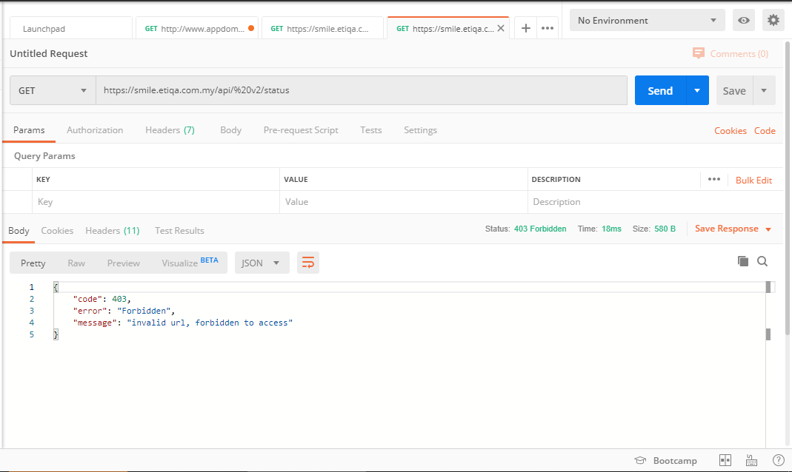

Response that I got using Google Chrome web browser:

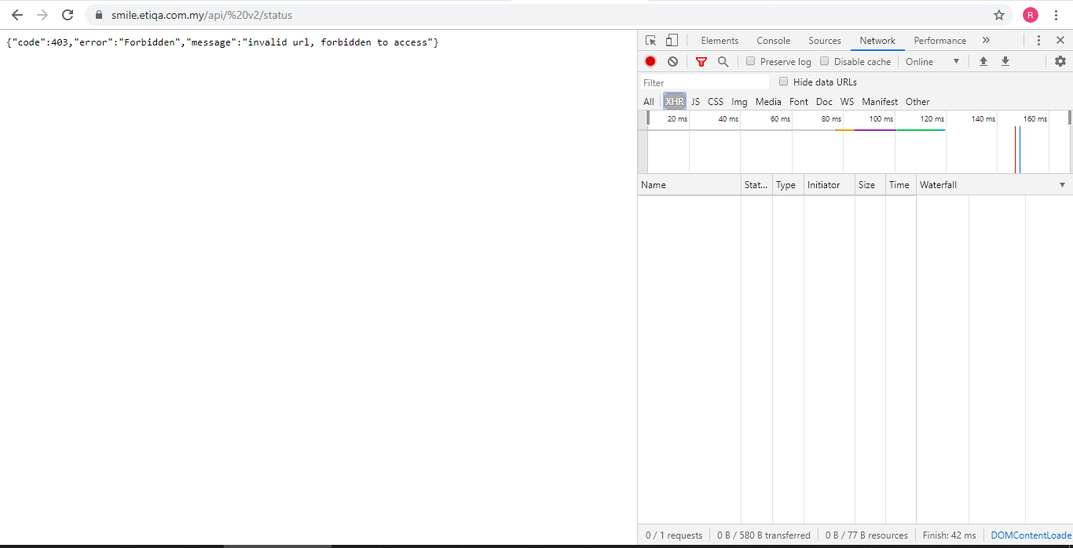

1. **Collaboration Knowledge**

I would recommend using **Anaconda Enterprise 5** as this involves collaboration. Once the software is installed, open Projects to view all projects, then choose which project to share and select share. Type the name of the user in the Add New Collaborator drop-down and press Add. The software compares the copy of the project files that Alice have locally with those on the server and notifies if any files have a conflict. If there is no file conflict, Bob’s local copies are updated. If there are any conflicts, select **Keep both and Pull** to save the conflicting files with different filenames.

1. **Explain**

* Mobile application frameworks
* **Ionic**
* **PhoneGap**
* **Xamrin**
* Backend solution, API
* **Angular**
* **Ember**
* **Flutter**
* Database solution, and related technology.
* **Laravel**
* **Zend**
* **CodeIgniter**

1. **Problem Solving**

def is_leap(year):

leap = False

if year % 4 != 0:

leap = False

elif year % 4 == 0:

if (year % 100 == 0) and (year % 400 != 0):

leap = False

else:

leap = True

return leap